Fitpage Coding Assignment

Lathireddi Ekalavya

[ekalavyalatchireddi123@gmail.com](mailto:ekalavyalatchireddi123@gmail.com)

Introduction

This **Node.js** backend project is designed to provide a robust event review system for managing data and user authentication, including email verification. It utilizes **Express.js** for handling HTTP requests and **MongoDB** as the database for data storage. The APIs have been extensively tested using **Postman** to ensure functionality and reliability.

The authentication system includes features such as password hashing using **bcrypt** for enhanced security**, email verification** to ensure valid user accounts, and **JWT tokens** for secure user **authentication** and authorization. These components collectively contribute to a stable and secure backend infrastructure for web applications.

Database Schemas Description

1. **Event Schema**:
   * **Description**: Defines the structure for storing event information.
   * **Fields**:
     + **eventName**: Stores the name of the event (String, required).
     + **summary**: Contains summary data for the event, including overall ratings and specific ratings for registration, event experience, and breakfast (Arrays with default values).
     + **date**: Records the date when the event information is added (Date, default: current date).

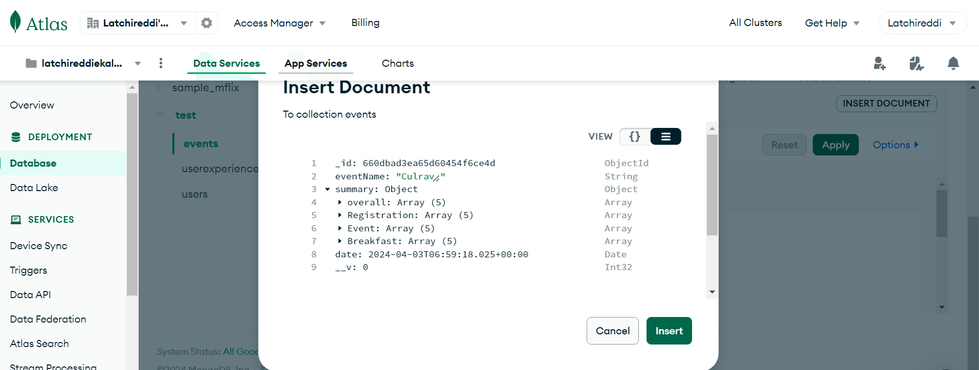

**Event Schema Example**

1. **User Schema**:
   * **Description**: Defines the structure for storing user information.
   * **Fields**:
     + **name**: Stores the user's name (String, required).
     + **email**: Stores the user's email address (String, required).
     + **password**: Stores the user's password (String, required).
     + **date**: Records the date when the user account is created (Date, default: current date).
     + **verified**: Indicates whether the user's email is verified (Boolean, default: false).
     + **manager**: Indicates whether the user has manager privileges (Boolean, default: false).

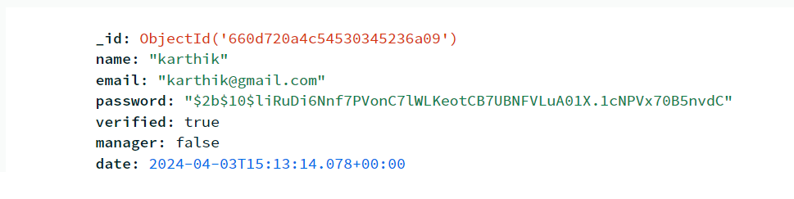

**User Schema Example**

1. **User Experience Schema**:
   * **Description**: Defines the structure for storing user experience related to events.
   * **Fields**:
     + **eventName**: Stores the name of the event related to the user experience (String, required).
     + **email**: Stores the user's email address (String, required).
     + **review**: Contains details of the user's review for the event, including registration, event experience, and breakfast (String with default values).
     + **rating**: Stores numerical ratings for registration, event experience, and breakfast (Numbers, required).
     + **overall**: Stores the overall rating given by the user (Number, required).
     + **likes**: Tracks the number of likes received for the user's review (Number, default: 0).
     + **reports**: Tracks the number of reports received for the user's review (Number, default: 0).
     + **reply**: Stores any reply added by the user or admin (String, default: empty).
     + **flag**: Indicates whether the review has been flagged (Boolean, default: false).
     + **date**: Records the date when the user experience data is added (Date, default: current date).

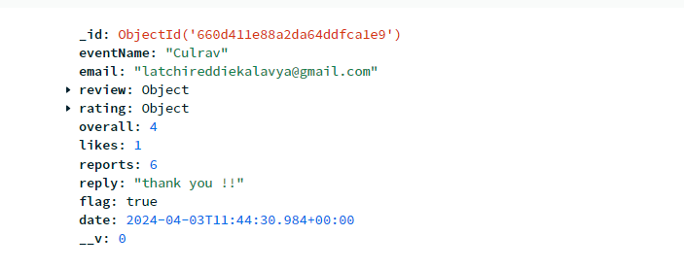

**User Review Schema Example**

Authentication (API End Points):

1. **POST /creatuser:**
   * Description: Creates a new user account with email, name, and password after checking if the email already exists.
   * Initial Check: Verifies if the provided email is not already registered. If it is, the API responds with a message indicating that the email is already in use.
   * Purpose: Allows users to register and create an account in the system while ensuring uniqueness of email addresses.
   * Request Body: Includes email, name, and password.
   * Response: Indicates success or failure of user creation, including messages for duplicate email or successful registration.

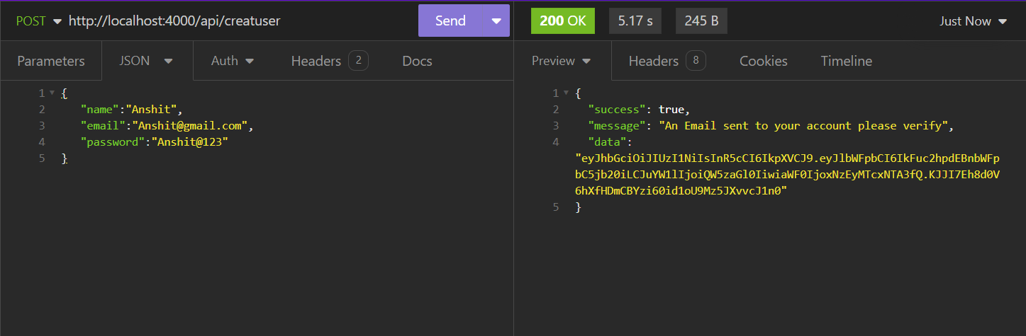

**It sends a email to user email with a token consist user data to verify**

1. **GET /loginuser/:email/:password:**
   * Description: Logs in a user with the provided email and password after validating the email format and password length.
   * Initial Check: Validates the email verified or not , if not verified then an email will be sent to user to verify.
   * Purpose: Authenticates users and generates a JWT token for authorized access.
   * Parameters: User email and password.
   * Response: Returns a JWT token upon successful login or indicates login failures.
2. **POST /verification:**
   * Description: Verifies the user's email address after registration.
   * Purpose: Marks the user as verified to access authenticated functionalities.
   * Request Body: Contains the user's email.
   * Response: Indicates success or failure of email verification.

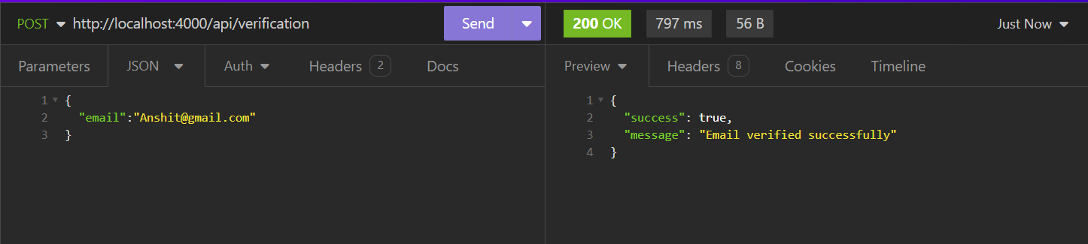**when user clicks on link that sent to email , this api call will be called**

1. POST /forgotPassword:
   * Description: Initiates the process to reset the user's password after checking if the email exists.
   * Initial Check: Verifies if the provided email is registered. If not, the API responds with a message indicating that the email does not exist.
   * Purpose: Provides a way for users to reset their forgotten passwords.
   * Request Body: Includes the user's email for password reset.
   * Response: Sends a password reset email if the email exists in the system.
2. **POST /updatePassword:**
   * Description: Updates the user's password after a password reset request.
   * Purpose: Allows users to set a new password after resetting the old one.
   * Request Body: Contains the user's email and new password.
   * Response: Indicates success or failure of password update after reset.
3. **POST /checkToken:**
   * Description: Validates the JWT token sent by the client.
   * Purpose: Ensures the authenticity and validity of JWT tokens for authorized actions.
   * Request Body: Contains the JWT token to be checked.
   * Response: Indicates whether the token is valid and associated with a user.
4. **GET /getUserDetails**:
   * Description: Retrieves user details based on the JWT token after validating its authenticity.
   * Purpose: Allows users to fetch their profile information securely.
   * Request Body: Contains the JWT token for authentication.
   * Response: Returns user details if the token is valid and associated with a user.

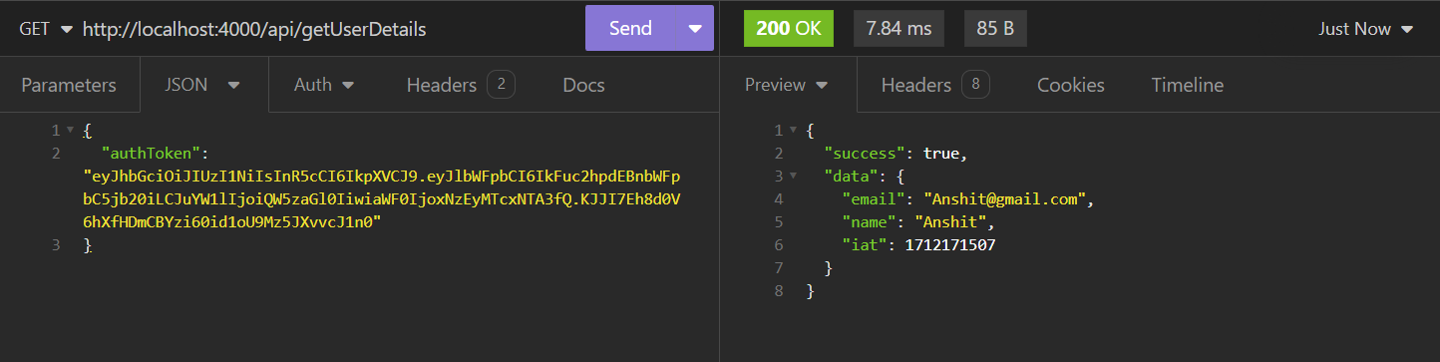

**Gives the user details from AuthToken**

Event Handler (API End Points)

1. **POST /createEvent:**
   * Description: Creates a new event after checking if it already exists.
   * Initial Check: Verifies if the event with the provided name already exists in the database.
   * Purpose: Allows the addition of new events to the system.
   * Request Body: Includes the event name.
   * Response: Indicates success or failure of event creation.
2. **PUT /:event/addReview:**
   * Description: Adds a review to a specific event after validating the email and event existence.
   * Initial Check: Validates the email format and checks if the event exists in the database.
   * Purpose: Enables users to submit reviews for events.
   * Request Body: Contains email, review details, ratings, and overall experience.
   * Response: Indicates success or failure of review submission.

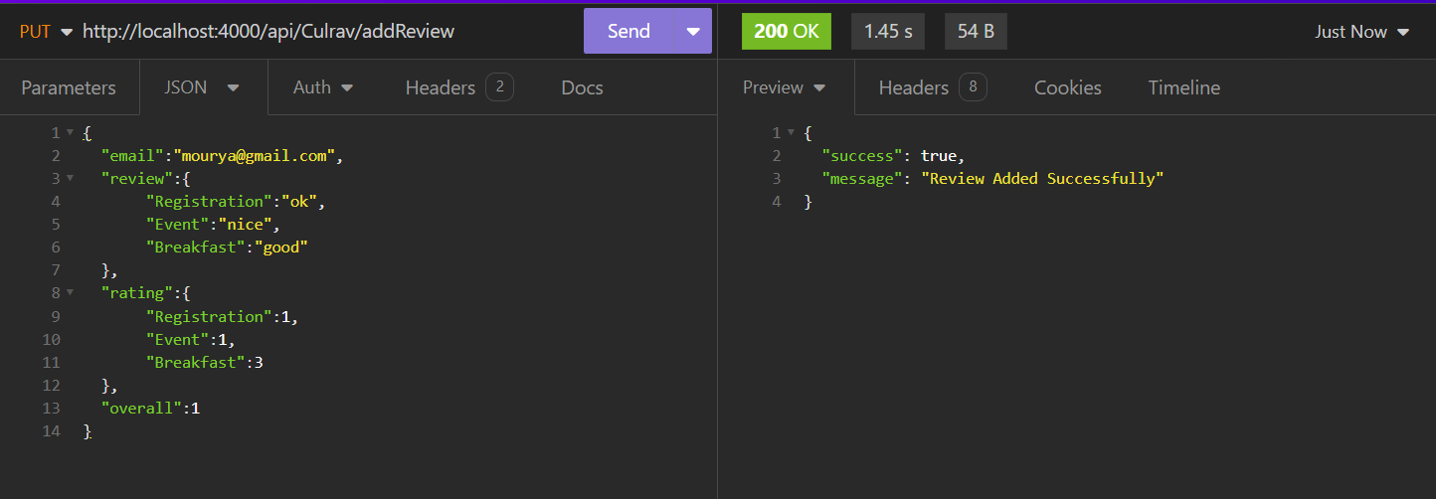

**Review will be added or updates review if review already exist by that user**

1. **GET /getReviews/:event/:startPage/:endPage:**
   * Description: Retrieves reviews for a particular event within a specified range of pages.
   * Initial Check: Verifies if the event exists in the database.
   * Purpose: Facilitates the retrieval of reviews for event analysis.
   * Parameters: Event name, start page, and end page for pagination.
   * Response: Returns reviews data within the specified page range.

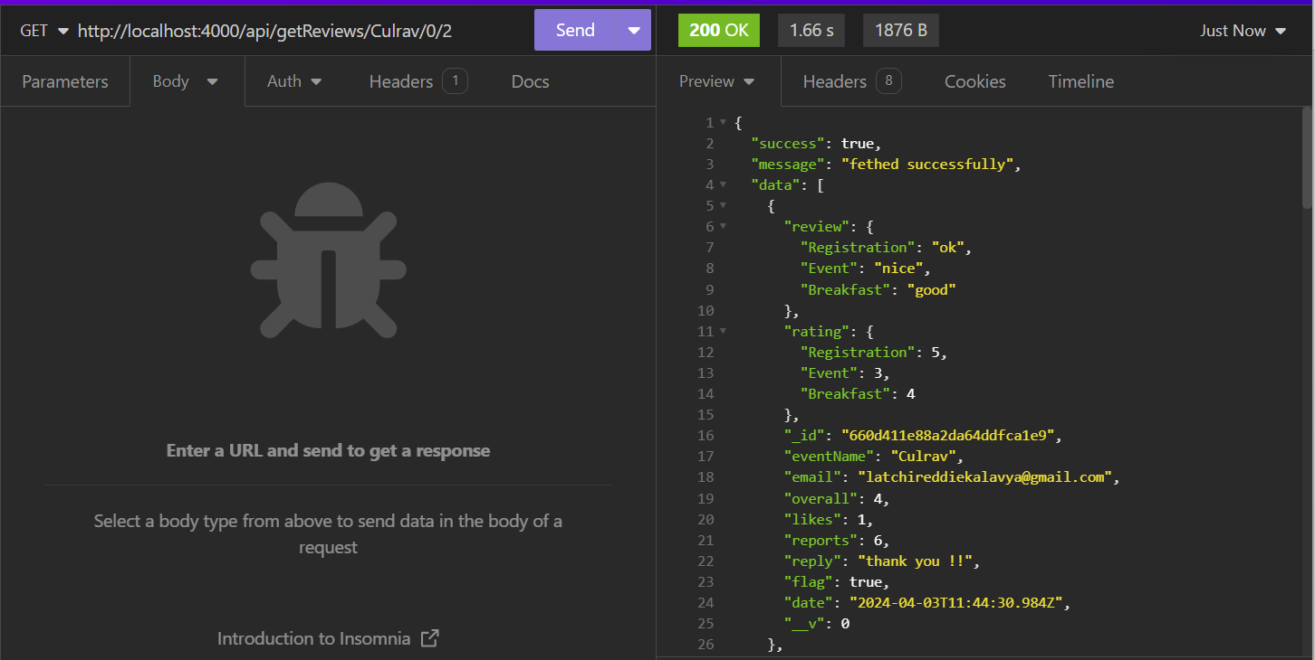

**Retrieve the reviews of specific event for the given range of pages**

1. **GET /getSummary/:event:**
   * Description: Fetches the summary data for a specific event.
   * Initial Check: Checks if the event exists in the database.
   * Purpose: Provides summarized data about an event.
   * Parameters: Event name for which summary is requested.
   * Response: Returns summarized data for the specified event.

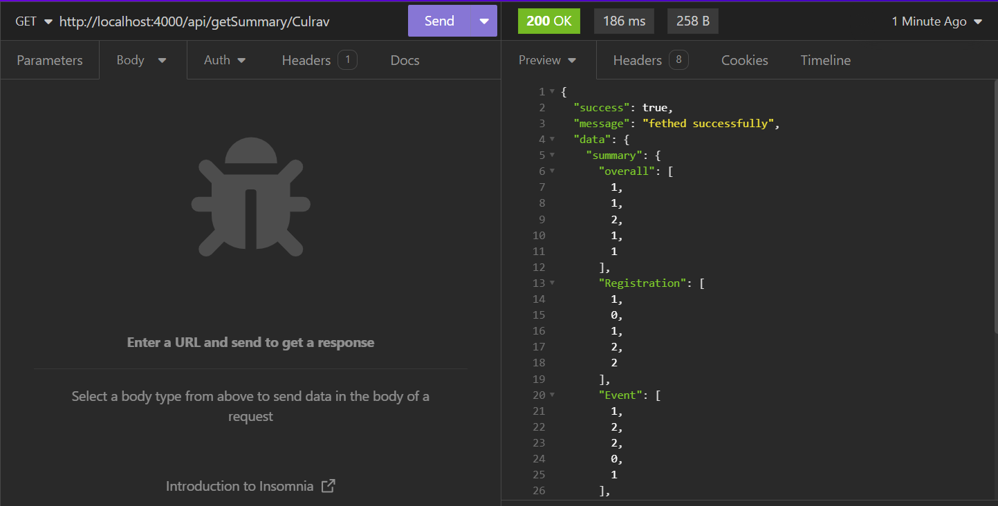

**Each category summary consist array of length 5 represents each stars count (like how many 1 star , 2 star , …. , 5 star came for that particular event**

1. **GET /getRatingByCriteria/:event/:criteria:**
   * Description: Retrieves ratings based on a specific criteria for a given event.
   * Initial Check: Validates the existence of the event in the database.
   * Purpose: Allows analysis of ratings based on different criteria for an event.
   * Parameters: Event name and criteria for which ratings are requested.
   * Response: Returns ratings data for the specified criteria of the event.

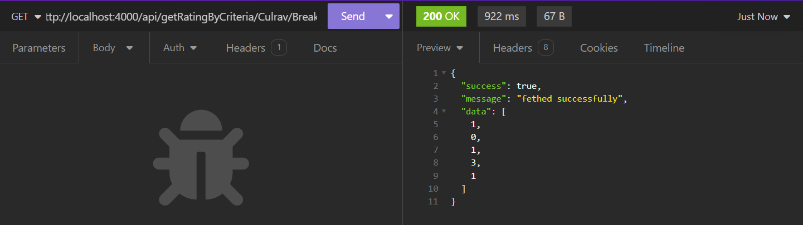

**For an event particular category summary , returns the array of 5 elements represents the total count of 1 start , 2 star , … , 5 star given by users**

1. **POST /:event/addReply:**
   * Description: Adds a reply to a user's review for a particular event.
   * Initial Check: Validates the email format and checks if the event exists.
   * Purpose: Enables event organizers or managers to respond to user reviews.
   * Request Body: Contains email, event name, and reply content.
   * Response: Indicates success or failure of reply addition.
2. **PUT /:event/addLike:**
   * Description: Increases the like count for a specific event's review.
   * Initial Check: Validates the email format and checks event existence.
   * Purpose: Allows users to like reviews for events they find helpful or enjoyable.
   * Request Body: Contains email and event name.
   * Response: Indicates success or failure of like addition.
3. **PUT /:event/report:**
   * Description: Reports an event's review, potentially flagging it for further review.
   * Initial Check: Validates the email format and verifies event existence.
   * Purpose: Enables users to report reviews that violate guidelines or are inappropriate.
   * Request Body: Contains email and event name for reporting.
   * Response: Indicates success or failure of the report submission.
   * **Note** : if reports become greater that 5 then flag tag will be activated to that review